**Experiment**

**Aim:** Write a shell script to understand case…esac statement

**Procedure:**

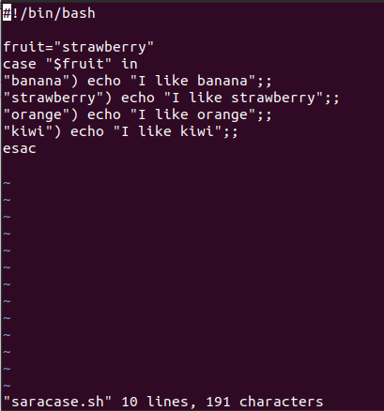

**Output:**

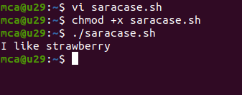

**Experiment**

**Aim:** Write a shell script to display the capital of a state using case…esac statement

**Procedure:**

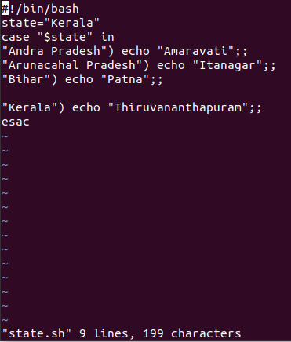

**Output:**



**Experiment**

**Aim:** Write a shell script to display the color in the rainbow state using case…esac statement

**Procedure:**

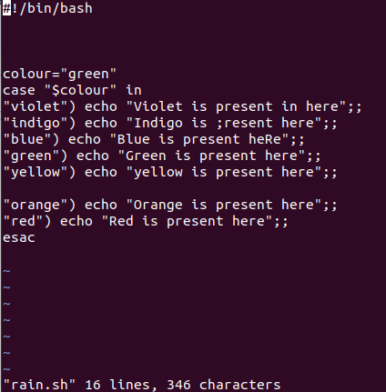

**User input:**

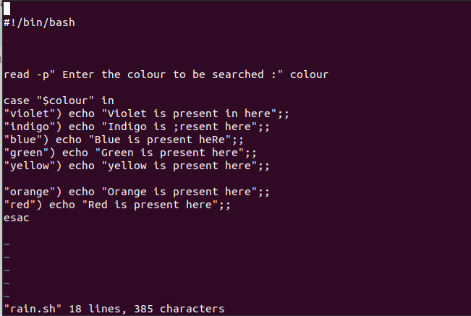

**Output:**

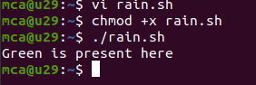

**Experiment**

**Aim:** Write a shell script to display the numbers in a certain limit using a while loop

**Procedure:**

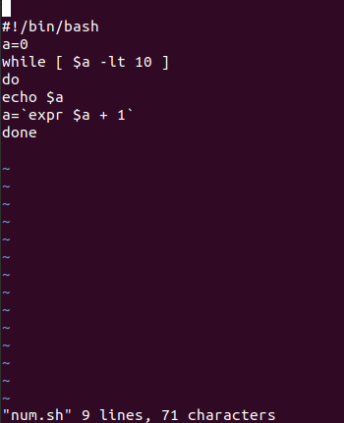

**Output:**

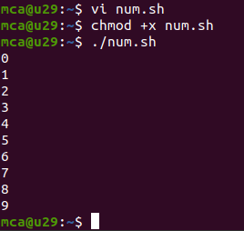

**Experiment**

**Aim:** Write a shell script to display the numbers in a certain limit using a while loop in reverse order

**Procedure:**

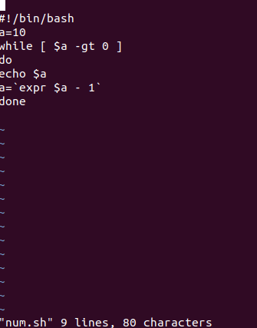

**Output:**

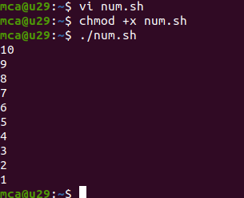

**Experiment**

**Aim:** Write a shell script to display palindrome using a while loop

**Procedure:**

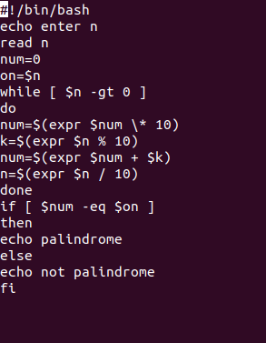

Output

**Experiment**

**Aim:** Implement for loop using break statement

**Procedure:**

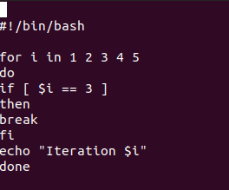

**Output:**

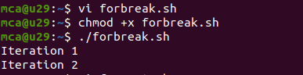

**Experiment**

**Aim:** Implement for loop to print numbers upto 10

**Procedure:**

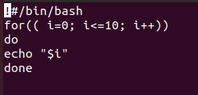

**Output:**

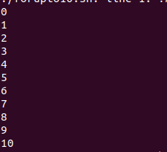

**Experiment**

**Aim:** Implement for loop to print numbers upto 0 for 10

**Procedure:**

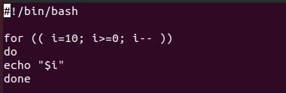

**Output:**

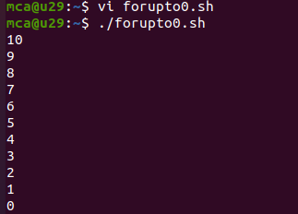

**Experiment**

**Aim:** Shell script to display numbers 2-15 using until

**Procedure:**

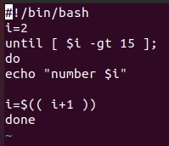

**Output**

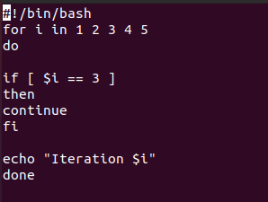

**Output:**



